Final Project Report: Low-Light Enhancement via RetinexNet
Course: Data Mining and Learning Systems
Institution: Braude College
Team Members: Katreen Ghobrial, Liel Etinger, Yohad Ben Baruch
1. Process of the Project Study (Problem Formulation & Theoretical Framework)
This project focuses on the self-governing study and implementation of deep retinex decomposition for low-light image enhancement. The core objective is to successfully estimate the intrinsic properties of an image from degraded, low-light observations. Traditional image enhancement algorithms often rely on global adjustments, which uniformly amplify both dark pixels and hidden digital noise, thereby distorting color fidelity.
To bypass these descriptive limitations and solve the problem with formal rigor, we investigated the Retinex theoretical framework. We formulate the problem using the classic Retinex mathematical model:
S = R I
Where S represents the observed low-light image (Source), R represents the intrinsic color and physical detail (Reflectance), I represents the lighting conditions (Illumination), and  denotes element-wise multiplication. Because we must recover two unknown matrices (R and I) from a single known matrix S, this is inherently an ill-posed mathematical problem.
To resolve this, we explored the RetinexNet architecture, a dual-network deep learning approach. The first phase, Decom-Net, learns to separate S into R and I without ground-truth datasets by enforcing physical loss constraints (Reconstruction Loss, Reflectance Consistency, and Illumination Smoothness). The second phase, Enhance-Net, adjusts the lighting, leading to the final reconstruction.
2. Project Flow & Implementation
The project flow began with migrating the foundational code implementation to Python Google Colab. During this phase, we debugged the provided architecture and fixed dependency errors to ensure the code executed correctly within the Colab environment.
Our implementation directly solves the formulated problem by establishing the neural network classes, loading pre-trained weights, and passing raw low-light image tensors through the Decom-Net and Enhance-Net models. While a formal Graphical User Interface (GUI) is not a necessary attribute of this system, we established robust array manipulation protocols using data visualization libraries to evaluate and control the input and output at every stage of the tensor flow. This allows us to extract and display the hidden matrices representing the intermediate Reflectance and Illumination maps.
3. Obtained Results & Analysis
Upon executing the implementation, the obtained results demonstrate that the network successfully decouples illumination from reflectance. The final reconstructed images show significantly improved brightness in shadowed regions while preserving the structural integrity and original color maps of the objects.
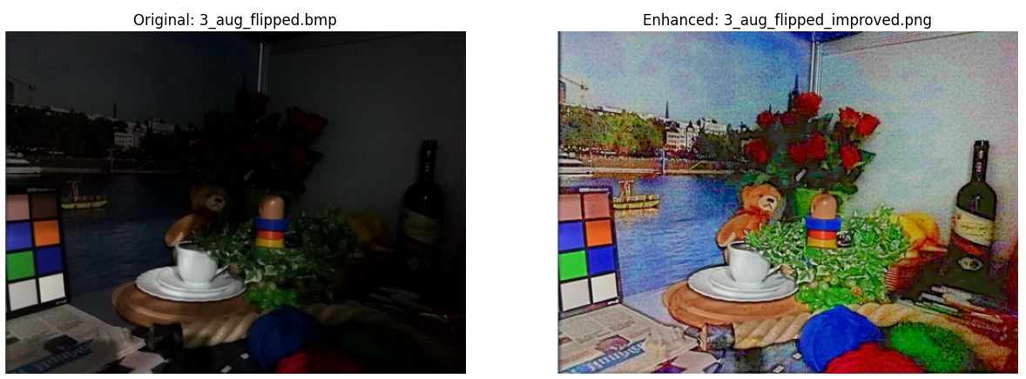
Analyzing the advantages and limitations of this approach reveals distinct trade-offs.
Advantages: The primary advantage is superior color fidelity. By strictly altering the I matrix and preserving the R matrix, RetinexNet prevents the washed-out effect common in heuristic filters. Furthermore, its ability to train on paired low/normal light images without requiring perfectly decomposed ground-truth data makes it highly scalable.
Limitations: The approach is computationally heavy compared to traditional methods. Additionally, if the spatial smoothness loss gradients are not perfectly balanced during evaluation, the network is prone to producing unnatural "halo" effects around high-contrast edges where physical shadows abruptly meet bright lights.
4. Conclusions
The RetinexNet implementation successfully bridges traditional color theory with modern neural networks. By mapping physical constraints such as the consistency of object color regardless of lighting into mathematical loss functions, the learning system effectively solves an ill-posed matrix decomposition problem. Ultimately, this self-governed study confirms that enforcing logical, theoretical rules upon data mining architectures allows deep learning models to independently deduce and isolate intertwined variables, resulting in a robust, mathematically sound method for low-light image enhancement.

